

Prepared by:

**Gerber Technology**

**YuniquePLM**

**YuniqueBI**

The Yunique Business Intelligence module is a graphic oriented interactive reports dash board that is unique to each user log in account. It allows users to be able to manage various activities on a “by exception” basis. To access Business Intelligence, click on the icon with the same name.

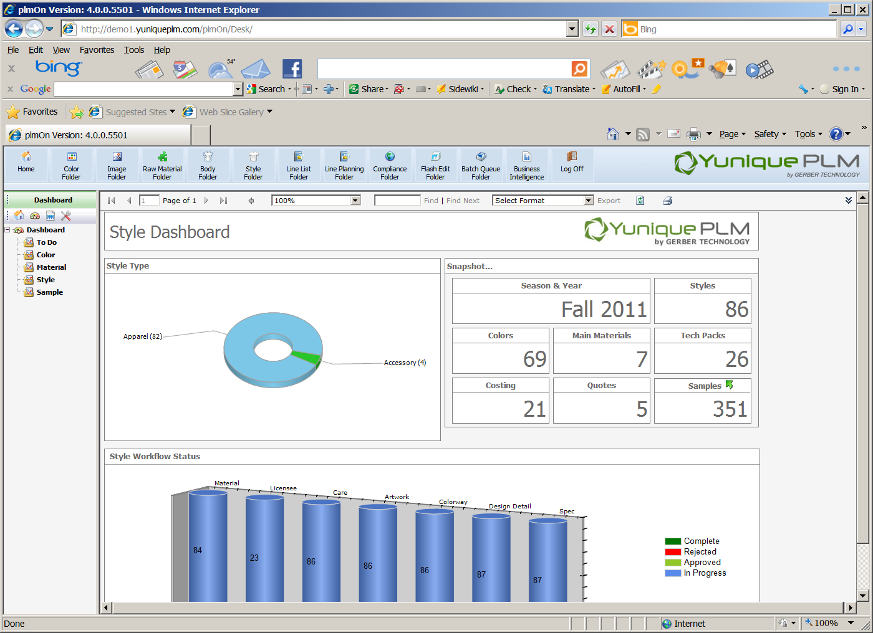

Upon opening, all of the available Dashboard reports will be listed on the left navigation. When a report is selected from the left navigation it will be displayed on the right.

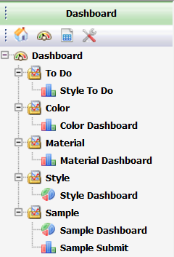

The available reports and the intended purposes are as follows:

Style To Do – graphically shows information related to all style folders by status

Color Dashboard - graphically shows information related to all colors by season

Material Dashboard - graphically shows information related to all raw material development

Style Dashboard - graphically shows information related to all style folders by style type

Sample Dashboard - graphically shows information related to all sample submits by status

Sample Submit - graphically shows information related to all sample submits by agent

While each of the dashboard reports has a specific purpose, the basic functionality for each is the same. For this reason, not all reports will be specifically documented. This document will focus on the Style To Do dashboard.

Click on the Style To Do header on the left had side of the explorer window to view the dashboard on the right side of the screen.

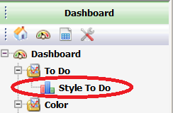

Once the dashboard is presented on the right side of the screen, it can be used to simple as a visual reference or it can be used to quickly access actual style data where further review or edits can be made. The style status area in the upper left quadrant of the screen visually displays a break-down of styles according to status. This area is for reference only.

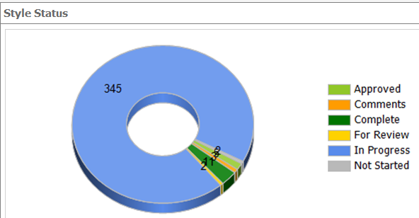

The Snapshot area in the upper right quadrant of the dashboard shows the number of tech packs that have been generated for style within a the selected season/year, as well as, how many colors are associated with all styles within that season, number of quotes, and costing. It also shows the number of sample requests for all styles.

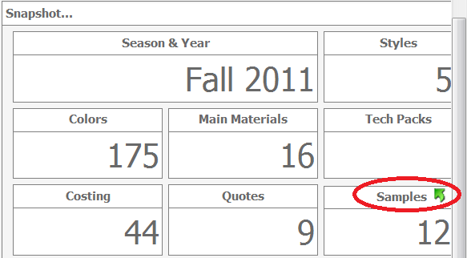

The sample header contains a green interactive arrow. Clicking on this arrow will actually drill into the Sample To Do dashboard where more in depth sample information can be reviewed.

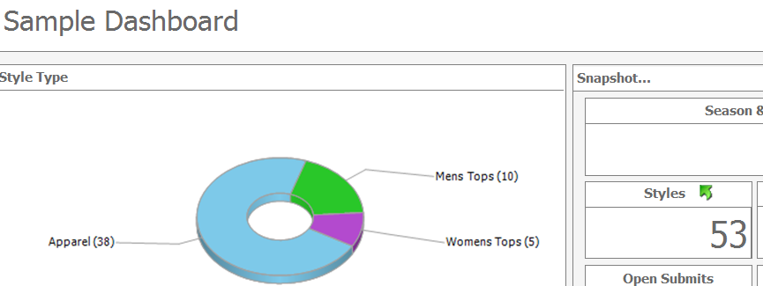

The lower half of the Style To Do dashboard graphically displays styles by workflow type

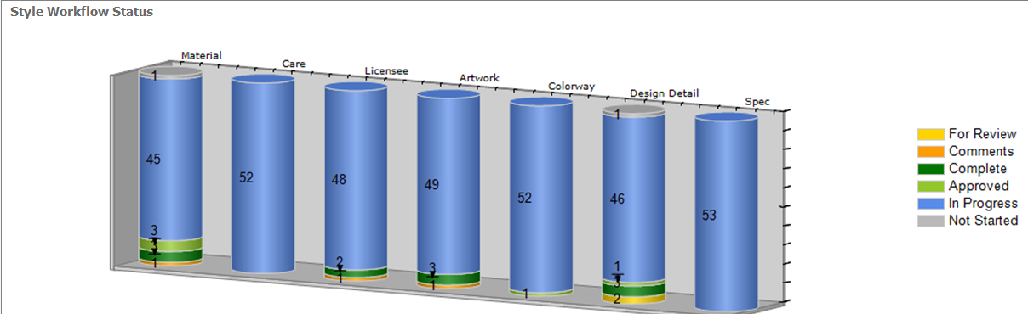

Each of the cylinder icons represents a different workflow type that has a corresponding dashboard. By clicking on one of the cylinder icons the specific dashboard will be displayed. For example to see a specific list of the styles with outstanding material request, click on the first cylinder icon labeled Material.

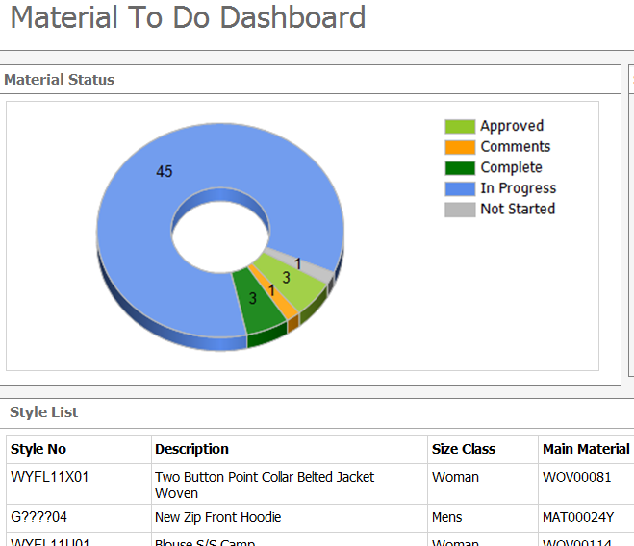

An individual style can be accessed by clicking on a specific style in the Style No list in the lower portion of a “To Do” dashboard.

**Managing Dashboard Views**

Each user can control the dashboard reports to meet individual business needs. To customize the view, select the desired dashboard report on the left side of the explorer window.



Once the report is visible on the right side of the screen, click on the double arrow icon in the upper right of the window.



This will open up the upper portion of the screen to present two new headers for filtering the reports. Reports can be filtered by season and year combinations and/or user groups or individual users. This means that information can be viewed at a companywide level for management or at a user level, so that each user sees only what he or she is responsible for completing.

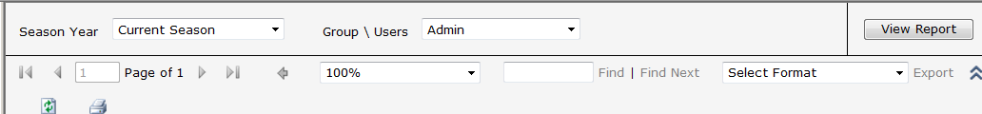

Once a report has been set to display as each user desires, data from each report can be exported to various formats for use outside of the YuniquePLM application. To export click in the Select Format drop down list in the upper right corner of the dashboard window and choose the desired format, then click the word Export to the right.

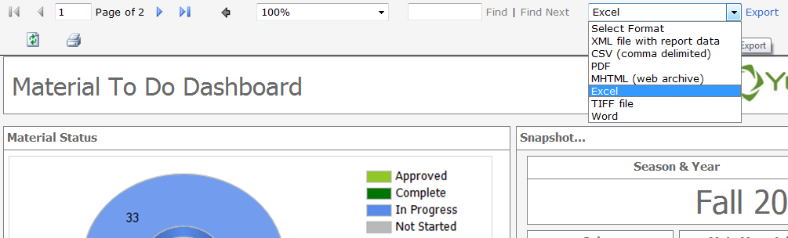

The report will be generated in the selected format and presented when the process is complete. The report will be presented in the requested form, but have the same appearance as the YuniqueBI interface.

Edits can be made to the newly generated report using the tools of the specific application. For example if Excel is selected for the export format, then formulas can be developed once the report is exported. The exported report formats exist outside of the Yunique application and therefore changes made in other applications cannot be uploaded or reflected in the YuniqueBI view.

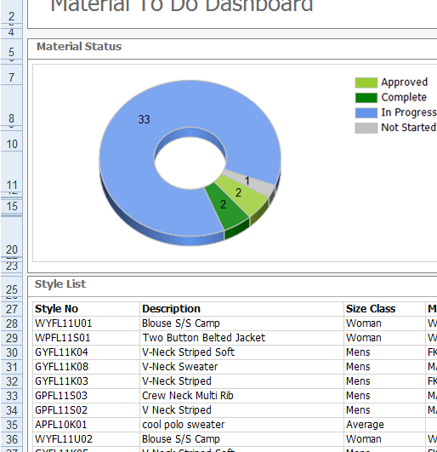

Yunique Business Intelligence also offers us additional reports.

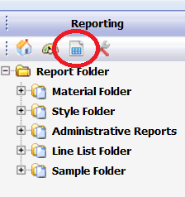

To access,click on the View Reports icon as shown above.

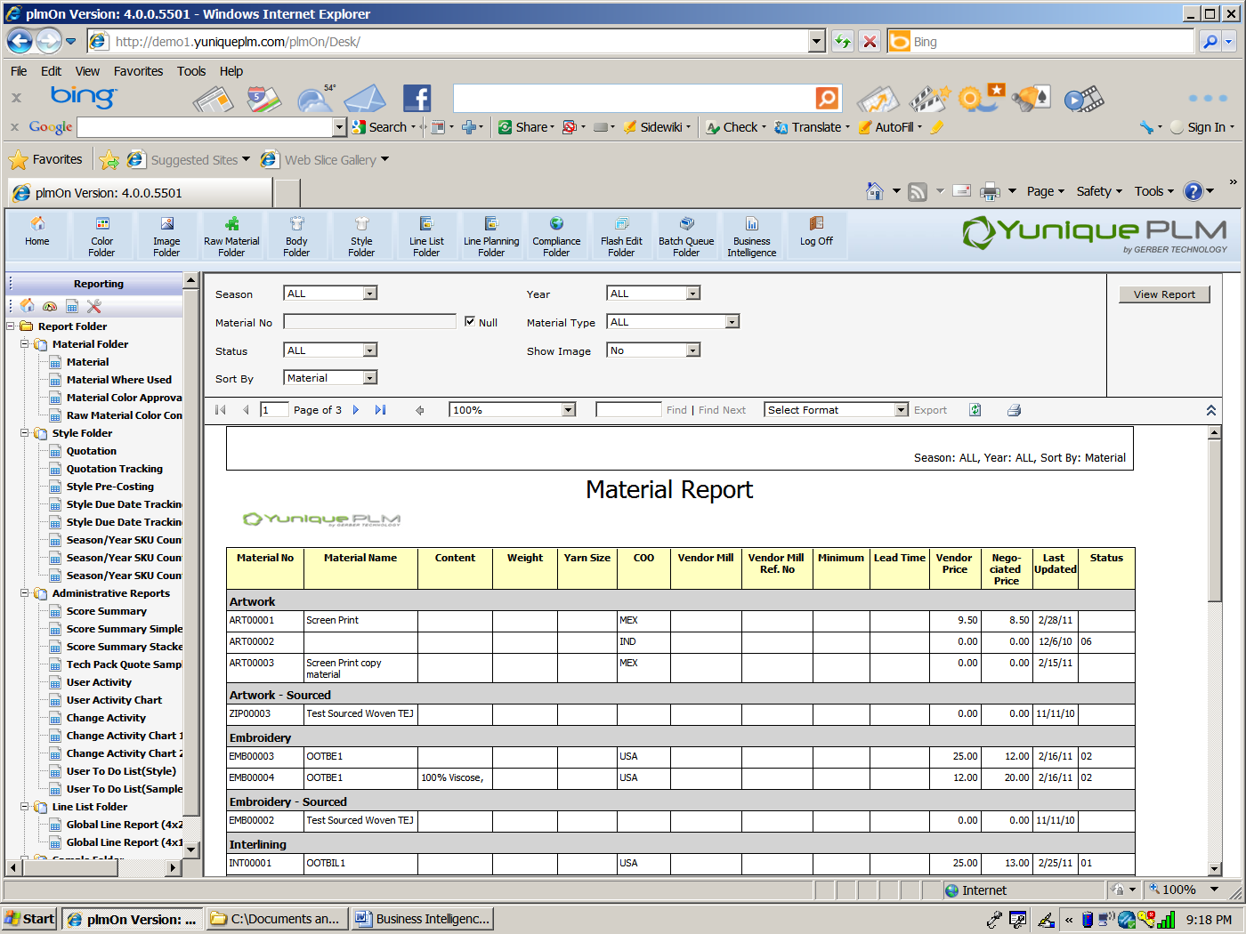

The left navigation will display the default reports that are available.

Shown in the example above is the filter that displays for the Material Report. Each report will have it’s own filters to use for reporting.